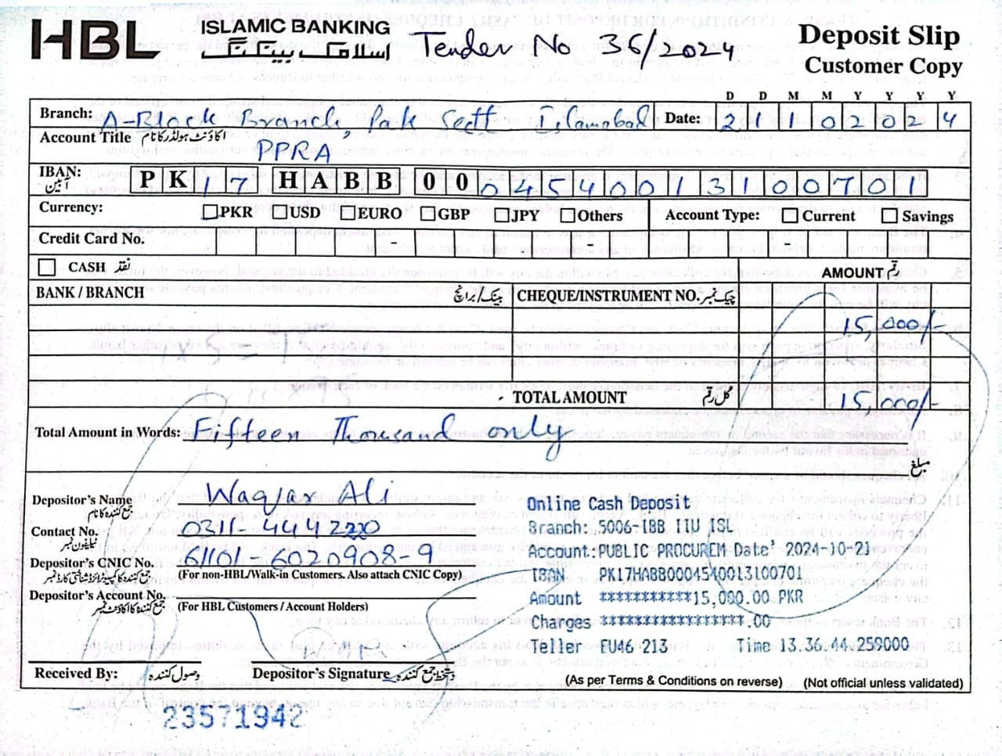
TENDER NOTICE NO. 36-38/2024

TENDER NOTICE FOR THE PURCHASE OF DIFFERENT MEDICAL EQUIPMENTS THROUGH OPEN TENDER

- A Public Sector Hospital invites sealed tenders from eligible / reputed firms / suppliers registered with income tax / general sale tax department for the purchase of different medical equipments under single stage – two envelopes bidding procedure from the eligible tenderers / suppliers / manufacturers for the following items on FOR Islamabad basis.
Sr. # | Tender No. | Description | Tender Fee | Last Date / Time of Bid submission | Bids Opening Date / Time
1. | 36/2024 | CO2 Laser (Dermatology Department) | 2,000/ | 11-11-2024  At 10:00 Hrs | 11-11-2024  At 10:30 Hrs
2. | 37/2024 | Dermatoscope (Dermatology Department) | 2,000/- | 12-11-2024  At 10:00 Hrs | 12-11-2024  At 10:30 Hrs
3. | 38/2024 | UVB Band Narrow Machine (Dermatology Department) | 2,000/- | 13-11-2024  At 10:00 Hrs | 13-11-2024  At 10:30 Hrs

- A set of tender documents along with terms and conditions can be downloaded from PPRA website: www.ppra.org.pk at a cost of Rs. 2,000/- separately for each tender payable in the shape of “Pay Order/Demand Draft” in favor of “Sr. Accounts Officer, Public Sector General Hospital, Islamabad”. The Pay Order/Demand Draft and tender request must be submitted separately along with tender proposals before closing date of tender. No Tender / Proposal will be accepted without Tender Fee.
- This tender can be seen on PPRA website www.ppra.org.pk also.

- The competent authority reserves the right to reject any or all the tenders.

Admin Officer
Public Sector General Hospital
H-11/4 Islamabad
Ph: 051-9257171
Ext: - 289

INSTRUCTIONS

TO FILL UP THE TENDER DOCUMENTS
Technical worksheet

- Download file named “Tender File CO2 laser” from URL: www.ppra.org.pk for quoting technical specification of “CO2 laser”.
- Open relevant file.
- Save the file when it is complete to fill up the cells of as many brands as you want to quote.
- Please write “NQ” against non-quoted items in empty cells.
- Technical Proposal should not indicate any price. There will be two different files; one for Technical Proposal only and one for Financial Proposal. All pages of hard copy should be stamped, signed and dated of Technical Proposal. The format of which is contained in the required proposal attached with tender documents available at PPRA website.
- In addition to the hard copy, a soft copy as CD should also be submitted with the technical proposal in MS Excel / MS Office format.
- The hard and soft copies should be identical.
- Variation in hard and soft copy will not be acceptable.
- Put duly signed / stamped print-outs and CD of “Technical” worksheet in an envelope and name it as “Technical Proposal” along with following documents:
- GST Certificate
- NTN Certificate
- Professional / Trade Tax Clearance Certificate
- Original Bank Draft of Earnest Money @ 2% of total value of contract
- Valid Authority/ Distribution letter
- Original Bank Draft of Rs. 2000/- as Tender Fee (in separate enlovep) and written request for purchase of said tender
- Agency agreement with manufacturer (foreign / local)

- Properly seal the envelope named “Technical Proposal”.

Financial worksheet

- Open same saved file again as above.
- Take print outs of “Financial” worksheet and sign & stamp each page.
- Write a CD or “Save As” the file in CD for making a soft copy of “Financial” worksheet (Keep it in mind that Technical worksheet will also be included in the saved file).
- Put duly signed / stamped print-outs and CD of “Financial” worksheet in an envelope and name it as “Financial Proposal”.
- Put both the envelopes named “Technical Proposal” and Financial Proposal” in a large envelope and Mark it as “Tender for CO2 laser” and properly seal it. Submit the tender documents to the specified address: Admin Officer, Public Sector General Hospital, H-11/4, Islamabad (PGHI) or directly drop it to the office of Procurement Branch, Islamabad.
TERMS & CONDITIONS
PAKISTAN ATOMIC ENERGY COMMISSION
GENERAL HOSPITAL H-11/4
ISLAMABAD
No. Hosp-1(1617)/24/Dermatology Dated: -10- 2024

M/S _
________________________________
________________________________

Subject: TENDER ENQUIRY FOR THE SUPPLY OF “CO2 LASER” THROUGH OPEN TENDER FOR FINANCIAL YEAR 2024
Dear Sir,
The following instructions may kindly be complied with while forwarding quotations for the supply of “CO2 laser” through open tender basis for financial year 2024 for PAEC General Hospital, H-11/4, Islamabad.

1. The quotations should be addressed to Admin Officer, Public Sector General Hospital, H-11/4, Islamabad. The bidders will submit their offers using single stage two envelopes bidding procedure as per following details:-

- The bid will be comprised of a Single Package Containing Two Separate Envelopes. Each envelope will contain separately the “Technical Proposal” and the “Financial Proposal” in both soft and hard copy in the shape of CD and print-outs respectively.

- The separate envelopes should be marked as “TECHNICAL PROPOSAL” and “FINANCIAL PROPOSAL” in bold and legible letters in order to avoid confusion.

- Initially only the envelopes marked as “TECHNICAL PROPOSAL” will be opened.

- The envelopes marked as “FINANCIAL PROPOSAL” will be retained in safe custody without being opened until opening date for financial proposals would be announced.

- The technical proposal will be evaluated without reference to any Price and any proposal that do not conform to the specified requirements will be rejected.

- No amendment in the Technical Proposal will be permitted during evaluation.

- The Financial Proposal of the bids will be opened publicly at a specified time, date and venue announced and communicated in advance to the bidders of technically accepted bids only. The Financial proposal of the bids found non-responsive or without offered rates will be returned to the respective bidder and would be treated as cancelled.

- The supplier is bound to replace the near expiry disposable stock at least six months before expiry date of supplied items failing which may result in deduction form any outstanding bill/invoice or performance bank guarantee.
General terms & conditions:

2. All the Technical Proposals and Financial Proposals in Separate Sealed Envelopes clearly marked as “purchase of CO2 laser” financial year 2024 should reach the undersigned on or before the tender opening date i.e. 11-11-2024 up to 10:00am. Technical bids of CO2 laser will be opened on 11-11-2024 at 10:30am in Conference Room, Raazi Block, Public Sector General Hospital, Sector H-11/4, Islamabad in the presence of bidders who would have submitted their offers as per instructions/ requirements and intend to be present. In case of falling holiday on the opening date, the tenders will be opened on the next working day at the same time.
3. No tender will be accepted if:-

- It is received after the time and date already fixed.
- The tender and related documents are not signed.
- The offer is ambiguous.
- Items offered differ in descriptions/requirements/format etc. from those required.
- It is submitted without tender fee, earnest money or with less earnest money as a general policy.

4. Following Documents must be attached with Technical Proposal:-

- GST Certificate
- NTN Certificate
- Profession / Trade Tax Clearance Certificate
- Original Earnest Money
- Valid Authority/ Distribution letter (Items quoted without authority letter will not be considered)

5. Firms are required to quote rates in Pak. Rupees. Offer shall remain valid for a period of 90 days from the date of opening of tender. The offer less than this period will be rejected.

6. Earnest money @ 2% total value of contract in the form of Pay Order/ Bank Draft, in favor of Sr. Accounts Officer, Public Sector General Hospital, Islamabad must be attached along with the Technical Offer in separate sealed envelope. Financial proposal should contain only offered price / rate.

7. Earnest money will be returned to the unsuccessful bidders soon after finalization of the financial proposal.

8. The bidder is required to present its agency agreement with the manufacturer (local or foreign) to establish linkage with the manufacturers for the products authorized for sale by the distributor. PGHI will have the right to verify authenticity of agency agreement.

9. The quantities to be purchased from the suppliers can be increased or decreased as per requirements of PGHI. The suppliers are to ensure timely delivery of equipments as specified failing to which liquidated damages / late delivery (L.D) charges will be applied @ 2% per day subject to a maximum of 10% of the purchase order.

10. Special Instructions:-

- GST may be charged as per Finance (Supplementary) Bill 2022.

- Only those firms will be considered as eligible to participate in this tender, which would have stock available with them.
- Suppliers/Distributors are bound to submit a valid authority letter/sole distribution certificate for all the quoted brands failing which offer will not be accepted and the same must be attached along with the TECHNICAL PROPOSAL.

- No change will be allowed during the currency of contract in supplier’s distribution and the supply orders will be generated in the name of same supplier quoted in the tender.

- Rates must be quoted in the specified file available on PPRA website. Any proposal submitted without observing the instructions will be rejected.

11. If the bidder / supplier unconditionally accepts all ‘Terms & Conditions’ of PGHI then participate in open tender and quote rates.
12. Any correspondence regarding this tender must be addressed to Admin Officer, Public Sector General Hospital, H-11/4, Islamabad only. For any additional information contact on telephone numbers mentioned below.

13. The Competent Authority reserves the right to accept or reject any or all the offers.

(Muhammad Anwar Kamal)
Admin Officer (Proc)
Public Sector General Hospital, H-11/4, Islamabad
Phone: 051-9257171 Ext: 289
Fax: 051-9258862

TECHNICAL SPECIFICATIONS OF CO2 FRACTIONAL LASER SYSTEM
Following are the minimum requirements. Products offered must meet these parameters here in.
General Specification

Laser Source: Metal Tube RF CO2 Laser.
Three Hand Pieces:
- Fractional Head (CO₂ Fractional Resurfacing)
- Surgical (Cutting)
- Erbium Glass Head
Application
1) CO₂ Fractional Mode)
- Anti-aging
- Derma pigmentation
- Wrinkle removal
- Scars (acne, surgical, Burn)
- Pores minimization
- Skin Tone & Texture
- Stretch Mark
- Fractional Skin Resurfacing
2) Infra-Red + Radio Frequency Mode
- Wrinkles
- Facial lifting
- Acne
- Pores minimization
3) Surgical Cutting Mode: -
Laser Specifications
- Wavelength: 10600 nm
- CO₂ Tube: RF - Metal Sealed
- Laser Power: 40 Watts or above
- Scanning size: 3 x 3 mm to 20 x 20 mm
- Probes: a) Fractional, b) IR+RF, c) Surgical, d) Erbium Glass Head
- Aiming Beam: 5mW 635 nm Diode
- Scan Mode: Standard, Random and scatter
- Scan Shapes: Square, Rectangular, Circle, Triangle ,Ellipse ,Line, Hexagon
- Applications: Wrinkle, face-lifting, acne, pores minimization, burnt scars,
        - surgery scars
- Spot size: 0.2mm
- Skin impedance: 0.5,0.7,1.0 sec, manual
- Cooling: Air cooling
- Display: Minimum 10 touch screen
Term & Condition
- Sole distributor certificate must be provided.
- FDA/ CE (MDD)/ MHLW (any one certifications required)

WARRANTY /GUARANTEE
- Two-years warranty with free service and part after installation and 10 years part availability at component level.

Manual: Two sets each of the following manual in English languages will be provided free of cost in original form.
- Operator/User Manual
- Complete Service Manuals with Mechanical Electrical/ Electronic & mechanical schematic circuit diagram.

Country of Origin: Korea, China, Turkey

